Project Design Phase-II
Data Flow Diagram & User Stories

Date | 25 December 2025
Team ID
Project Name | SmartBuy-E_Commerce-Application
Maximum Marks | 4 Marks

Data Flow Diagrams:
Example: DFD Level 0
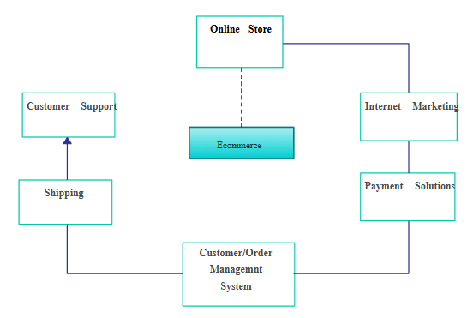

Users browse products, add items to cart, place orders, make payments, and leave reviews. Admin manages products, orders, and users.

User Stories

User Story Table – Freelance Finder
User Type | Functional Requirement (Epic) | User Story / Task | Acceptance Criteria | Priority | Release
Customer | Product Browsing | Browse and search products | Search bar must return relevant results within 2 seconds. | High | Sprint-1
Customer | Cart | Add products to cart | Cart icon must update the item count in real-time.  Users can modify quantities or remove items within the cart.  System must calculate the subtotal and estimated taxes automatically. | High | Sprint-1
Customer | Checkout & Payment | As a customer, I want to make secure payments so that my transaction is safe. | System must support Credit/Debit cards and Digital Wallets.  Payment data must be encrypted (PCI-DSS compliant).  User must receive an order confirmation screen and email after successful payment. | High | Sprint-2
Admin | Management | Manage products & orders | Admin can Add, Edit, or Delete product listings (CRUD).  Admin can change order status (e.g., Pending, Shipped, Delivered).  Dashboard must show low-stock alerts when inventory drops below 5 units. | High | Sprint-1

